

Step1: Open the CST studio suite and click on CST MICROWAVE STUDIO.

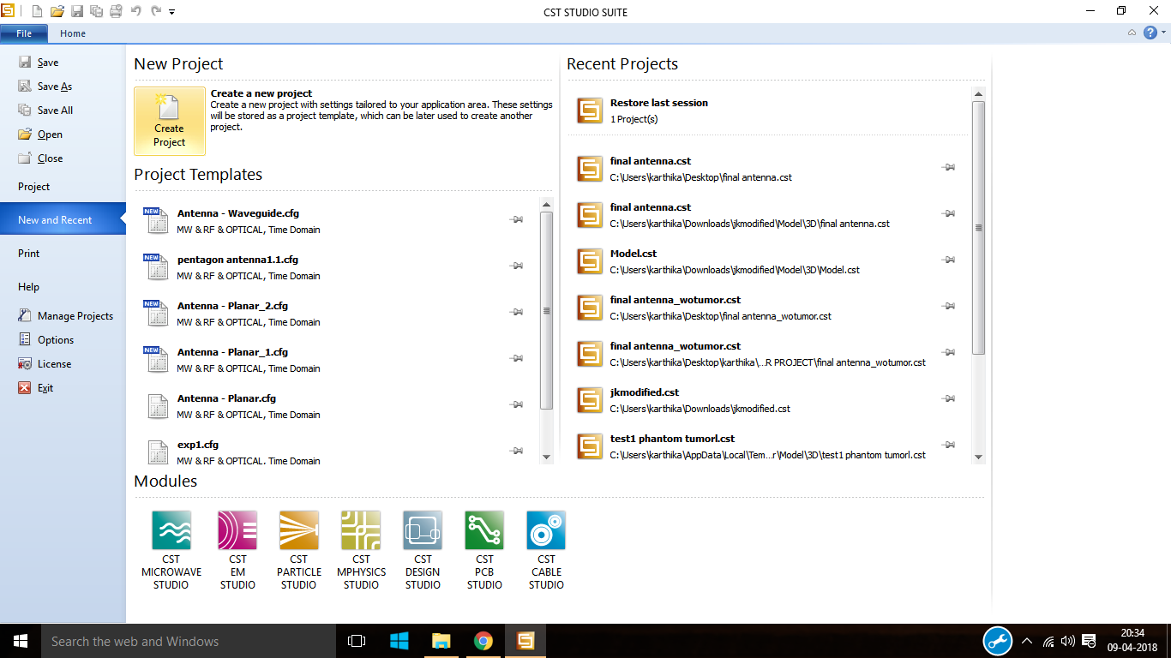

Step2: Click on create project from new project.



Step3: click on microwave and RF and Optical from create new template.



Step4: after that click on antennas.



Step5: click on antenna and then click on OK.

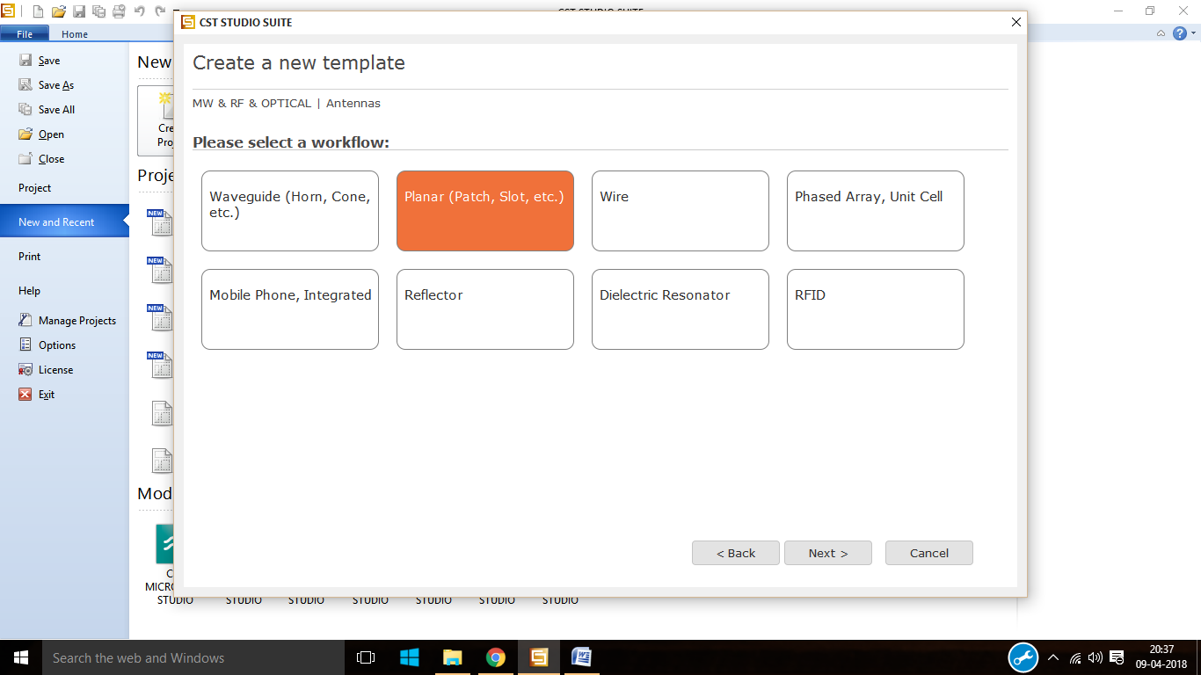

Step6: From the work flow click on planar.



Step7: select time domain as the solver.



Step8: select the units and then click on next.

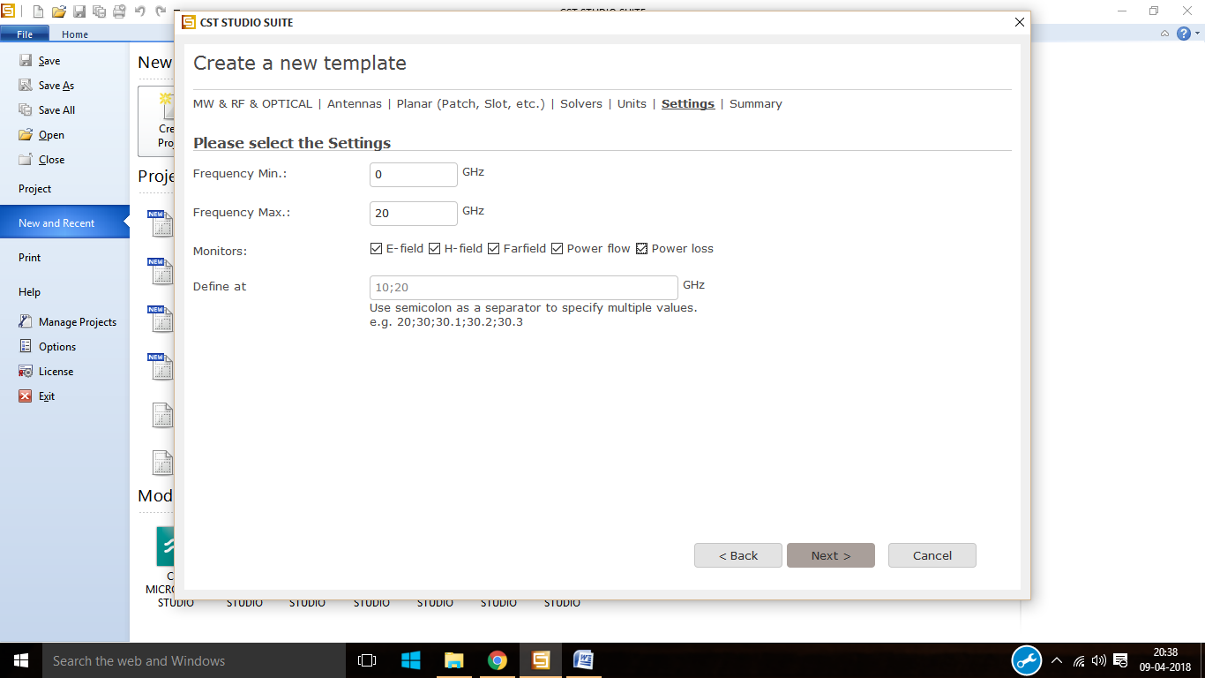

Step9: select the minimum and maximum frequency then select the required field monitors.

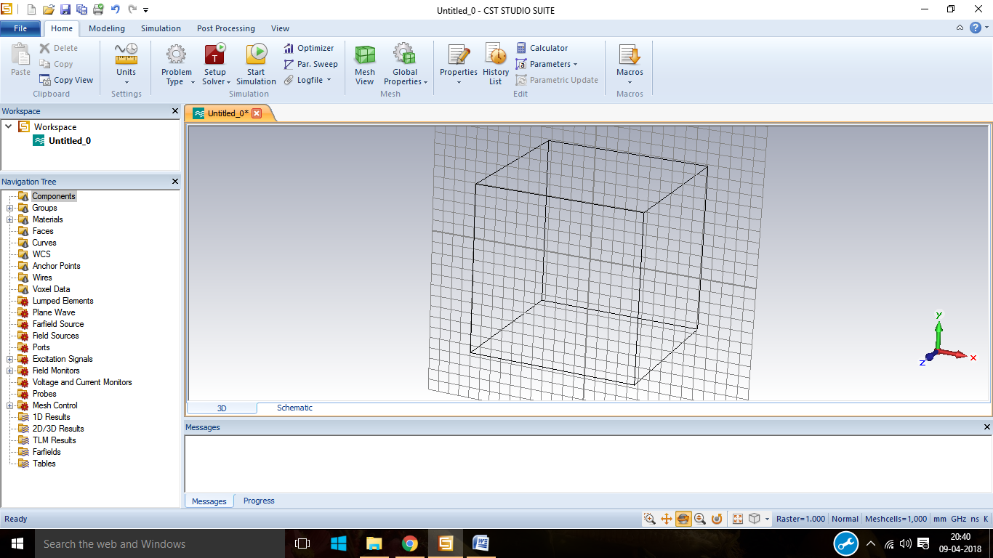

Step10: after all the initial setup is over the working plane appers.

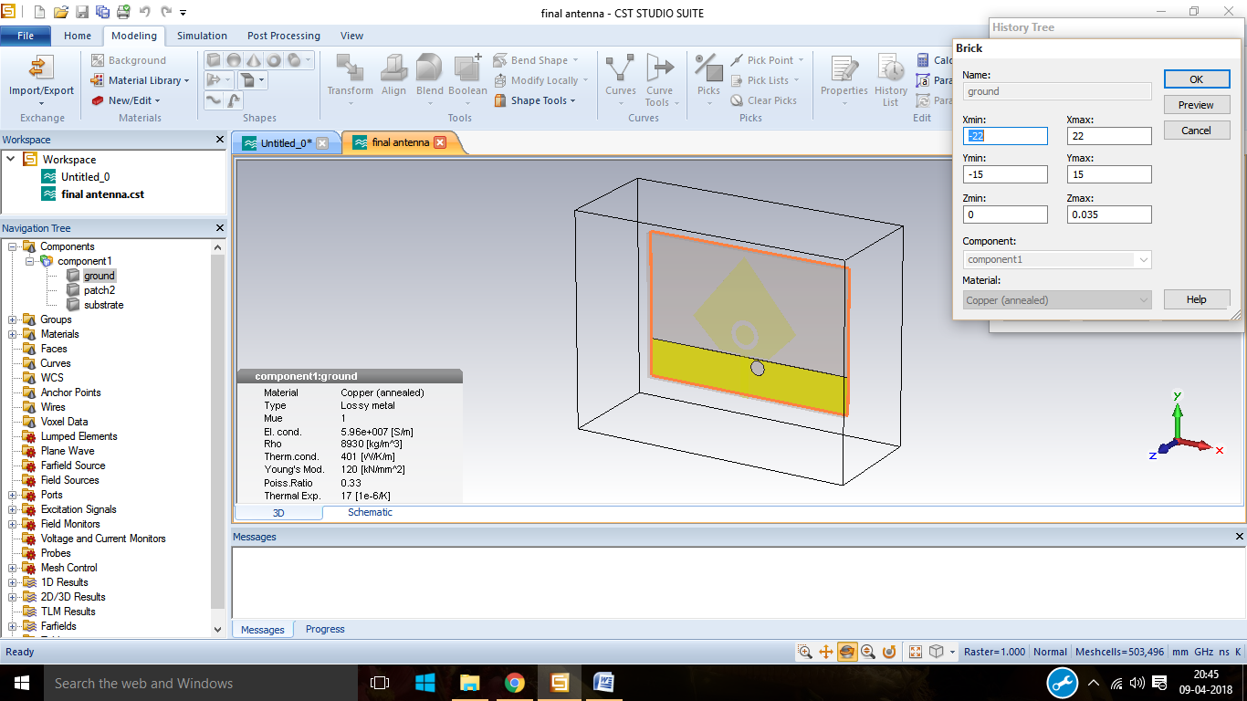

Step11: click on brick and specify the dimensions of the ground.

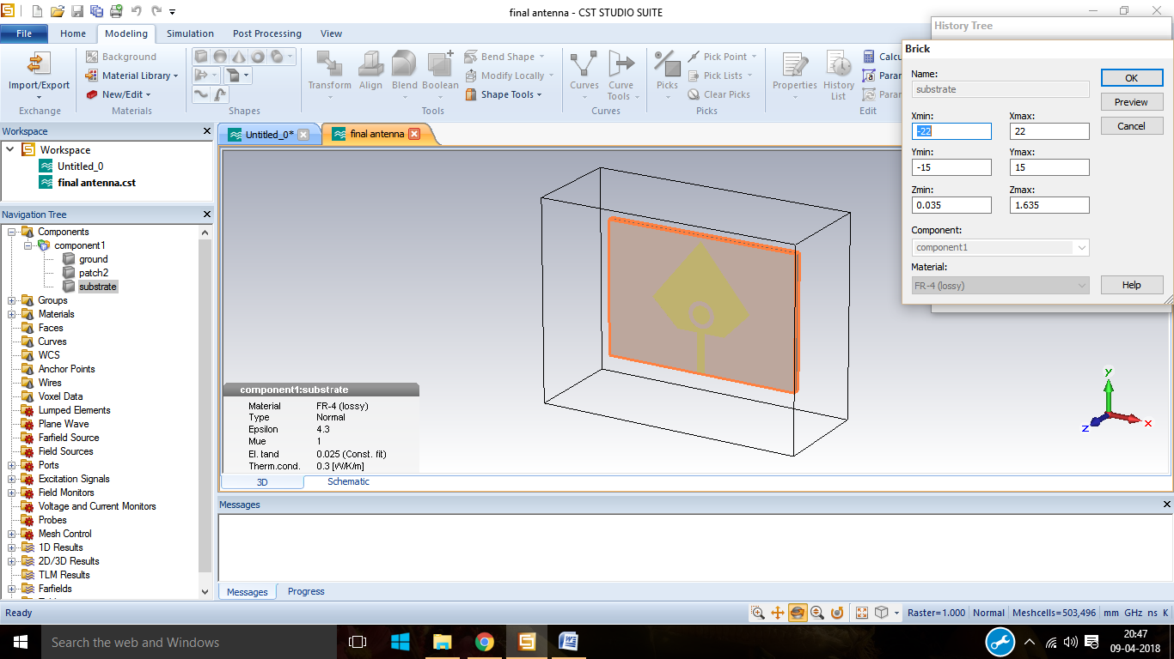

Step12: again click on brick and specify the dimensions of the substrate.

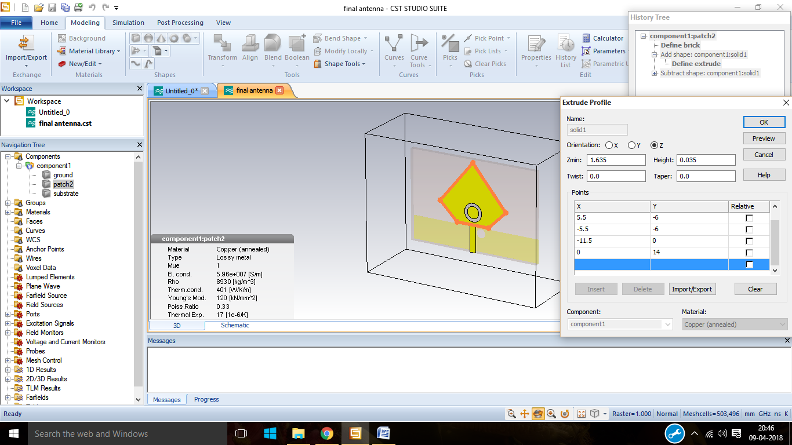

Step13: click on extrudes and then specifies the patch dimensions. Then give the dimensions for the feed line and add Boolean.

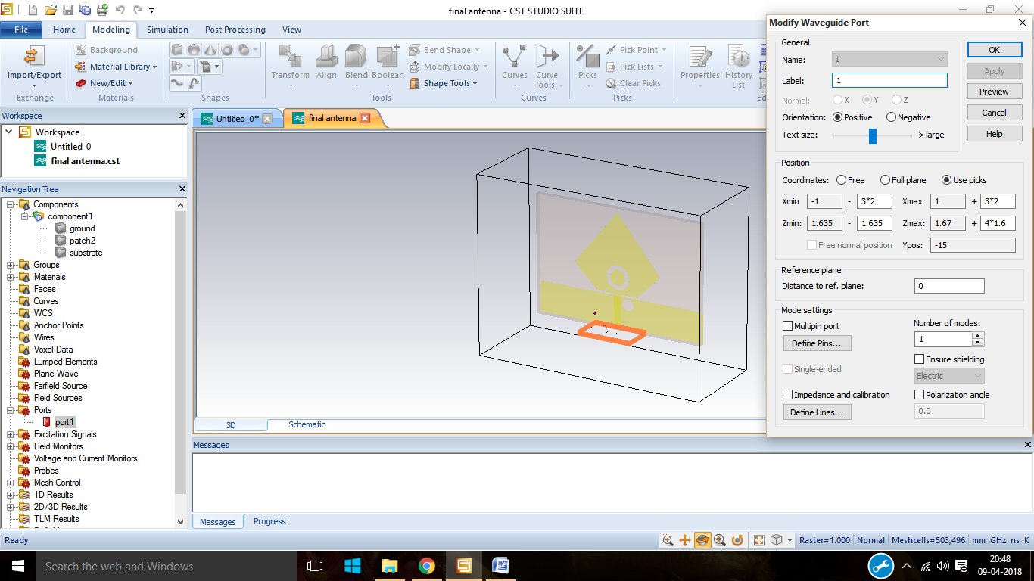

Step14: After designing the antenna go for the waveguide, select the waveguide port.

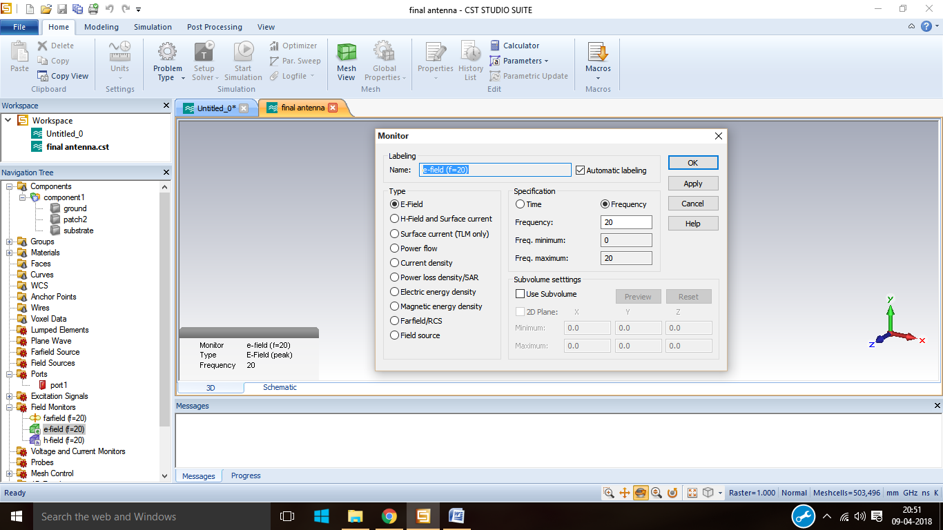

Step15: from the field monitor select E-Field and then click OK.

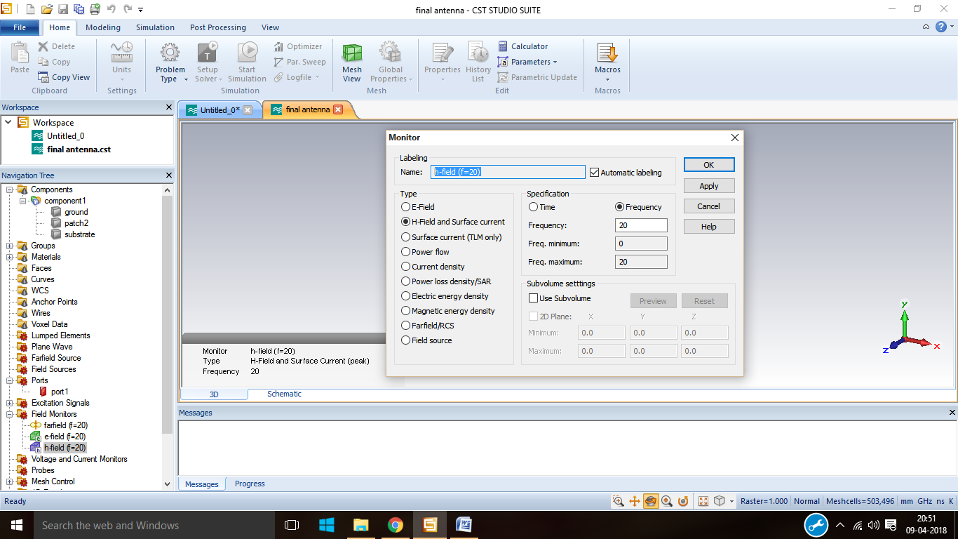

Step16: from the field monitor select H-Field and then click OK.

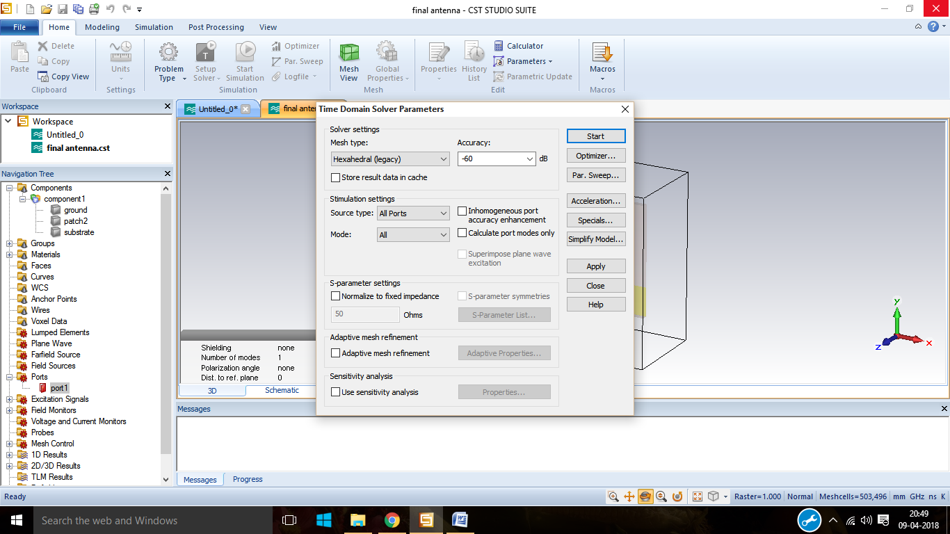

Step17: click on time domain solver and specify the mesh type, accuracy then click on start.

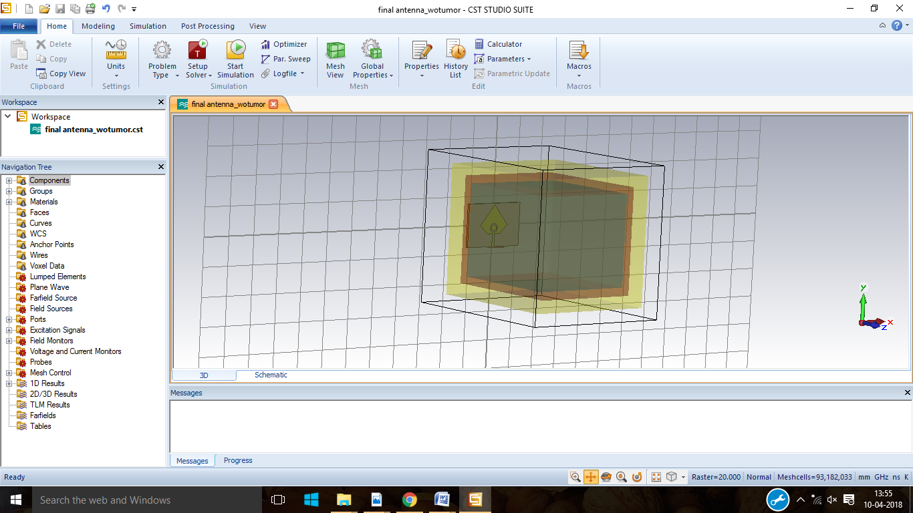

Step18: again click on brick and design the head phantom with different layers like skin, skull and brain.

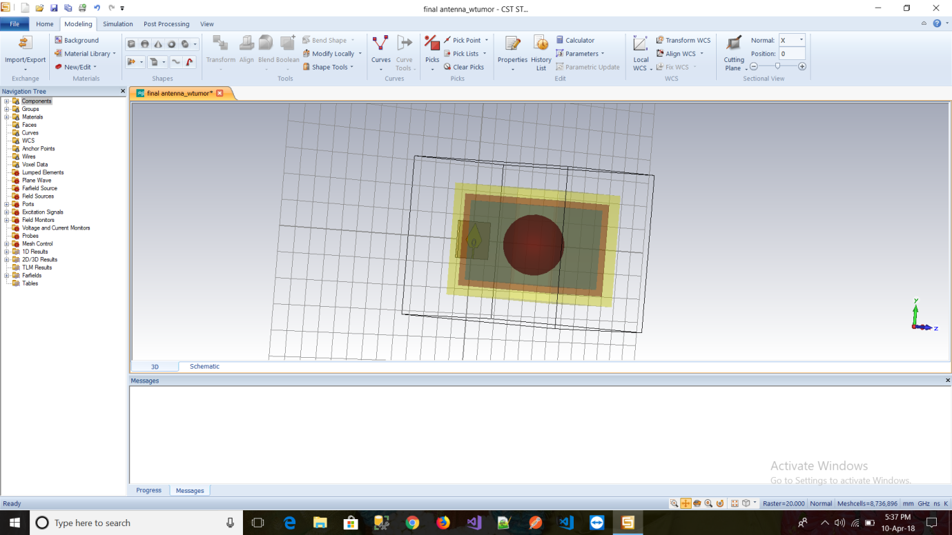

Step19: now click on sphere and the insert a tumour inside that head phantom.

Designed final antenna gain:

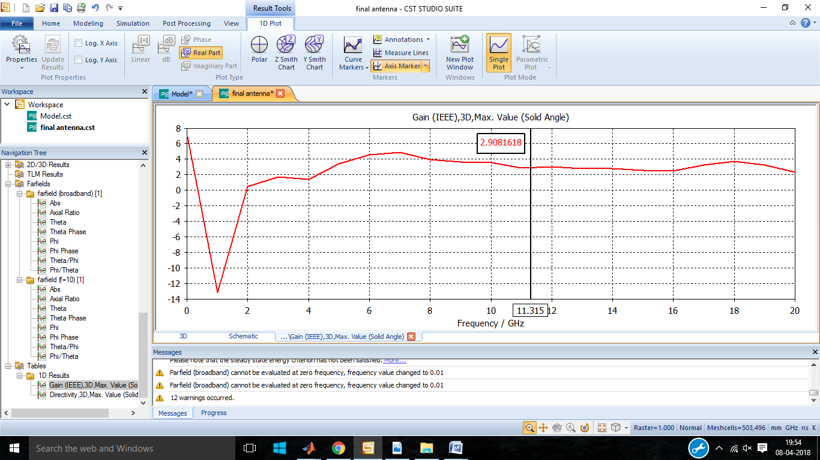

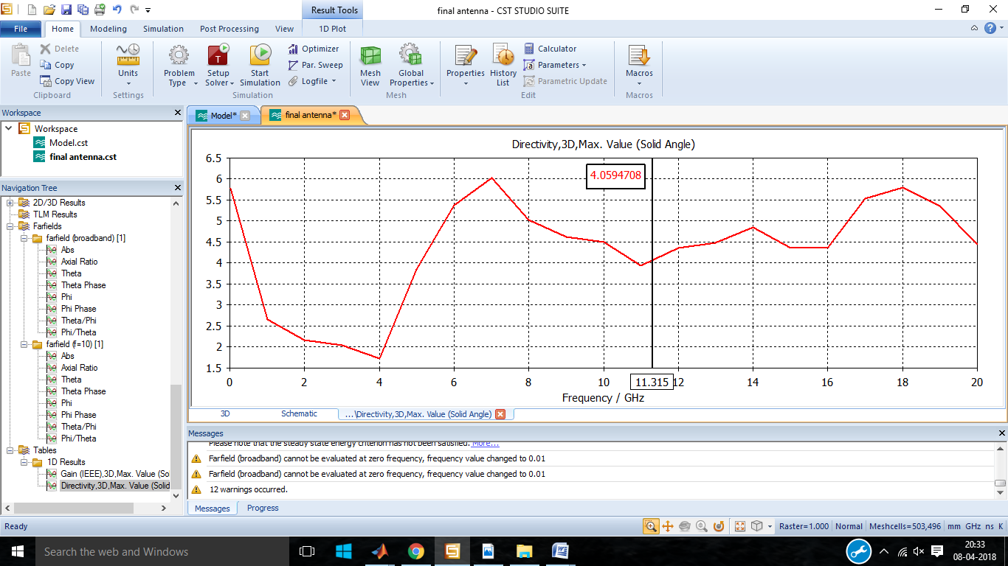

The above diagram shows the gain and directivity of the designed antenna at resonant frequency.

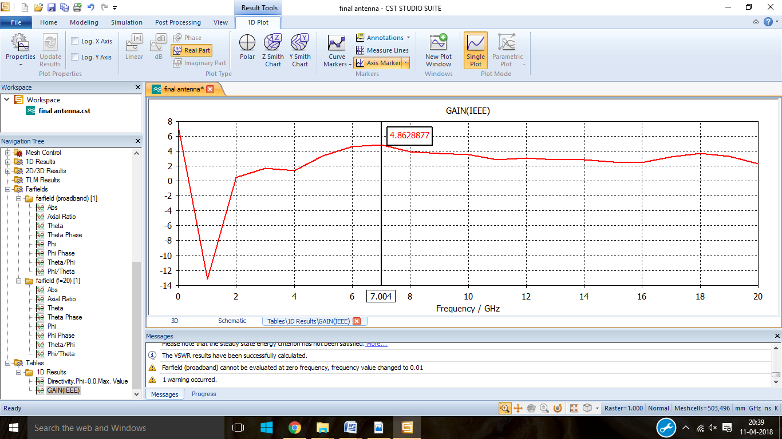

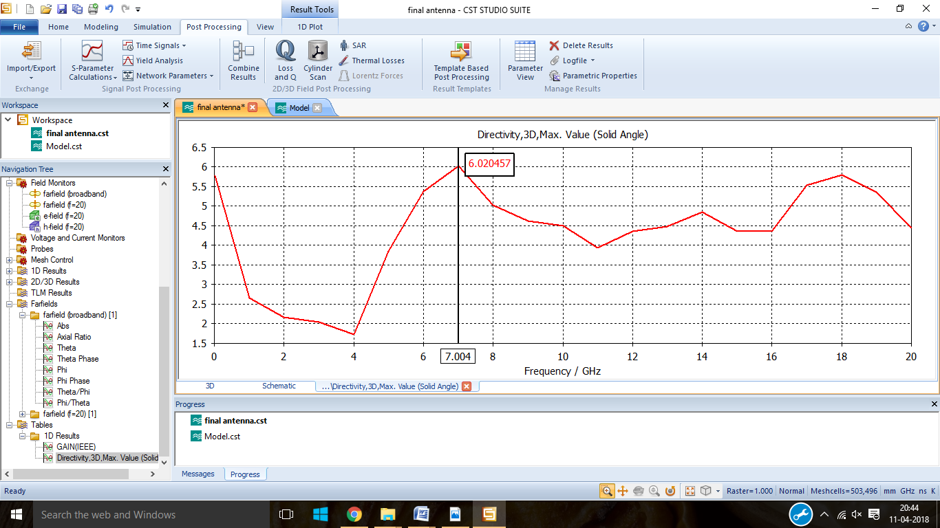

The above two diagram shows the maximum gain and maximum directivity of the designed antenna.

Step20: Open MATLAB and import the S11 value to MATLAB and write the coding in order to find the various statistical parameters.

**STATISTICAL PARAMETERS ANALYSIS CODE FOR WITHOUT TUMOR:**

clc;

a=load('antennawotumor.txt');

db1=a(:,2);

freq=a(:,1);

figure;

plot(freq,db1, 'r');

%mean

M=mean(a);

%median

m1=median(a);

%mode

m2=mode(a);

%variance

V=var(a);

%standard deviation

S = std(a);

%skewness

Y = skewness(a);

%kurtosis

K = kurtosis(a);

%rms

R = rms(a);

%max value

m = max(a);

%crest factor

C=m/R;

%min

m3=min(a);

%max

m4=max(a);

%correlation coefficient

r1 = corrcoef(a);

%covariance

c1 = cov(a);

**STATISTICAL PARAMETERS ANALYSIS CODE FOR WITH TUMOR:**

clc;

b=load('antennawtumor.txt');

db1=b(:,2);

freq=b(:,1);

figure;

plot(freq,db1, 'g');

%mean

M=mean(b);

%median

m1=median(b);

%mode

m2=mode(b);

%variance

V=var(b);

%standard deviation

S = std(b);

%skewness

Y = skewness(b);

%kurtosis

K = kurtosis(b);

%rms

R = rms(b);

%max value

m = max(b);

%crest factor

C=m/R;

%min

m3=min(b);

%max

m4=max(b);

%correlation coefficient

r1 = corrcoef(b);

%covariance

c1 = cov(b);

**MEAN CODING:**

clc;

a=load('sta_mean.txt');

Mean1=a(:,3);

values=a(:,1);

figure;

bar(values,Mean1);

**MEAN PLOT VALUES:**

1 9.999999719 -12.24

2 9.999999719 -13.28702932

3 9.999999719 -13.29741501

4 9.999999719 -13.29304115

5 9.999999719 -13.30591563

6 9.999999719 -13.26611528

7 9.999999719 -13.32171898

8 9.999999719 -13.28093548

9 9.999999719 -13.2863800

**MEDIAN CODING:**

clc;

a=load('sta_median.txt');

Median1=a(:,3);

values=a(:,1);

figure;

bar(values,Median1);

**MEDIAN PLOT VALUES:**

1 10 -10.545259

2 10 -12.17841

3 10 -12.164191

4 10 -12.220494

5 10 -12.169069

6 10 -12.270272

7 10 -12.330421

8 10 -12.056046

9 10 -12.083577

**MODE CODING:**

clc;

a=load('sta_mode.txt');

Mode1=a(:,3);

values=a(:,1);

figure;

bar(values,Mode1);

**MODE PLOT VALUES:**

1 0 -53.278161

2 0 -48.81407

3 0 -51.297492

4 0 -51.20911

5 0 -51.381762

6 0 -46.472155

7 0 -51.145957

8 0 -48.749993

9 0 -49.713907

**VARIANCE CODING:**

clc;

a=load('sta_var.txt');

var1=a(:,3);

values=a(:,1);

figure;

bar(values,var1);

**VARIANCE PLOT VALUES:**

1 33.43339813 57.15194809

2 33.43339813 60.44834968

3 33.43339813 60.16073728

4 33.43339813 60.437711

5 33.43339813 60.56364158

6 33.43339813 60.57688912

7 33.43339813 61.78774303

8 33.43339813 60.08765462

9 33.43339813 61.85915441

**STANDARD DEVIATION CODING:**

clc;

a=load('sta_stadev.txt');

stadev1=a(:,3);

values=a(:,1);

figure;

bar(values,stadev1);

**STANDARD DEVIATION PLOT VALUES:**

1 5.782162064 7.201030366

2 5.7822 7.7103

3 5.782162064 7.7563353

4 5.782162064 7.774169473

5 5.782162064 7.782264554

6 5.782162064 7.753554019

7 5.782162064 7.860517987

8 5.782162064 7.78684946

9 5.782162064 7.736869807

**SKEWNESS CODING:**

clc;

a=load('sta_skewness.txt');

skewness1=a(:,3);

values=a(:,1);

figure;

bar(values,skewness1);

**SKEWNESS PLOT VALUES**

1 -1.02E-09 -1.186214039

2 -1.02E-09 -0.9394

3 -1.02E-09 -1.002683189

4 -1.02E-09 -1.0031843963

5 -1.02E-09 -1.008993767

6 -1.02E-09 -0.876283972

7 -1.02E-09 -1.0135318115

8 -1.02E-09 -0.948532823

9 -1.02E-09 -0.981771766

**RMS CODING:**

clc;

a=load('sta_rms.txt');

rms1=a(:,3);

values=a(:,1);

figure;

bar(values,rms1);

**RMS PLOT VALUES:**

1 11.54989145 14.45923407

2 11.5499 15.3601

3 11.54989145 15.39226698

4 11.54989145 15.39747631

5 11.54989145 15.41267431

6 11.54989145 15.31366009

7 11.54989145 15.46590487

8 11.54989145 15.34313766

9 11.54989145 15.37293887

**MINIMUM VALUE CODING:**

clc;

a=load('sta_minval.txt');

minval1=a(:,3);

values=a(:,1);

figure;

bar(values,minval1);

**MINIMUM PLOT VALUES:**

1 0 -53.278161

2 0 -48.81407

3 0 -51.297492

4 0 -51.20911

5 0 -51.381762

6 0 -46.472155

7 0 -51.145957

8 0 -48.749993

9 0 -49.713907

**MAXIMUM VALUE CODING:**

clc;

a=load('sta_maxval.txt');

maxval1=a(:,3);

values=a(:,1);

figure;

bar(values,maxval1);

**MAXIMUM PLOT VALUES:**

1 20 -1.4097133

2 20 -1.2326

3 20 -1.2980227

4 20 -1.2395168

5 20 -1.2597655

6 20 -1.2827153

7 20 -1.2834004

8 20 -1.2145383

9 20 -1.2097204

**KURTOSIS CqODING:**

clc;

a=load('sta_kurtosis.txt');

kurtosis1=a(:,3);

values=a(:,1);

figure;

bar(values,kurtosis1);

**KURTOSIS:**

1 1.799997603 5.193021555

2 1.8 4.7829

3 1.799997603 5.0298065939

4 1.799997603 5.0349582619

5 1.799997603 5.0141542459

6 1.799997603 4.436943215

7 1.799997603 5.0928408841

8 1.799997603 4.862600376

9 1.799997603 5.02858943

**CREST FACTOR CODING:**

clc;

a=load('sta_crestfac.txt');

cretfac1=a(:,2);

values=a(:,1);

figure;

bar(values,crestfac1);

**CREST FACTOR:**

1 0.614987582

2 0.57

3 0.569824067

4 0.571990662

5 0.570376536

6 0.574476936

7 0.566699313

8 0.571642906

9 0.570321992

**COVARIANCE CODING:**

clc;

a=load('sta_covar.txt');

covar1=a(:,3);

values=a(:,1);

figure;

bar(values,covar1);

**COVARIANCE :**

1 33.43339813 -8.481574227

2 33.43339813 -15.68071411

3 33.43339813 -15.62508933

4 33.43339813 -15.6919399

5 33.43339813 -15.72476233

6 33.43339813 -15.65834788

7 33.43339813 -15.67401908

8 33.43339813 -15.59864564

9 33.43339813 -15.68816913

**CORRELATION COEFFICIENT:**

clc;

a=load('sta_correlation.txt');

correlation1=a(:,3);

values=a(:,1);

figure;

bar(values,correlation1);

**CORRELATION COEFFICIENT:**

1 1 -0.19072239

2 1 -0.351726974

3 1 -0.348398017

4 1 -0.349085952

5 1 -0.349452249

6 1 -0.353828267

7 1 -0.34485692

8 1 -0.350952432

9 1 -0.350684615